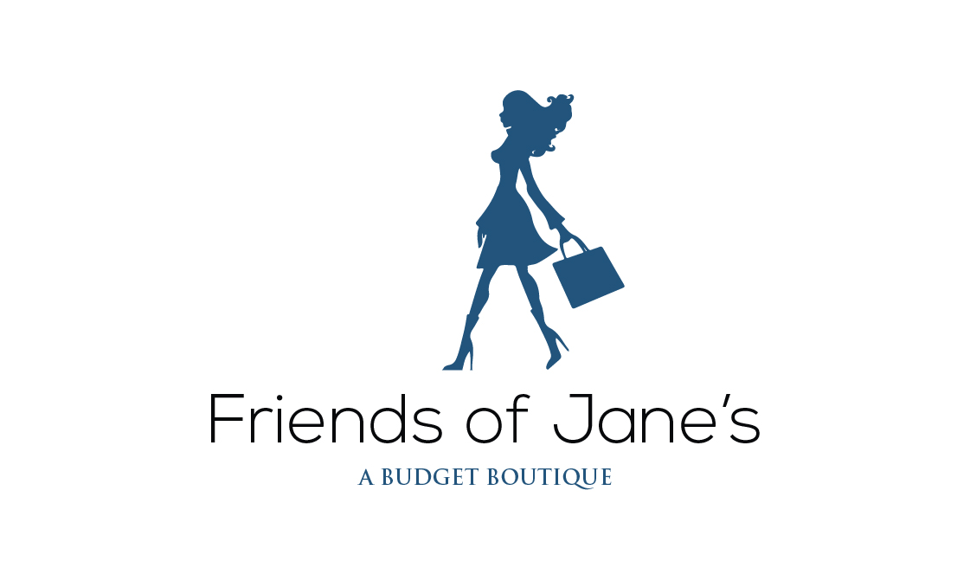
Business Partner #: ____________________ ______ Date: _________________________________
Name: ____________________________________ Phone:________________________________
Address:_______________________________________________________________________________
Email: _________________________________________________________________________________

Partnering with us is very easy! Before you decide to become a partner you should know:

- You will receive your own specific partner number that will be the same every time you drop items off. We work with a drop off only basis, which means we do not sort your items with you when you bring them in, Instead, your partner number will be attached to your drop off and sorted in order. Although we promise to do our best 100% of the time. Friends of Jane’s cannot be held responsible for lost, stolen or damaged items.
- Pricing is determined by staff, and we highly recommend that you have a look around the store at our prices points. As a partner, you receive 40% of the actual selling price of the merchandise.
- It could take up to four weeks for your items to be sorted and inventoried into our computer system. At the high point in each season, this could take a little longer. Items are placed on the floor for a period of 30 days, which includes a sale period if necessary. Your items will not go on the floor all at the same time. We reserve the right to alter these schedules at any time.
- We do not sell bras, underwear, prom dresses, wedding dresses, household items, or maternity clothing. Nor do we sell perfume/skincare items that have been opened.
- Your items should be dropped off freshly laundered and neatly folded in a bag.
- We only accept current, trend conscious items. With some exceptions items purchased in the past 3 years are generally okay and accepted. Anything older will be donated to support local charities.
- We only accept current, trend conscious items if they are in good, like new condition. We request that you do a pre-sort of any items that are stained, have holes, have pilling or have any other condition issues, and not included them. Items that do not match our condition standards will be donated to support local charities.
- Due to storage issues, it is impossible for us to return any unsold or unaccepted items. We donate everything, unaccepted or unsold on to support local charities. We accept on average, only 30% of what is dropped off. We reserve the right to reject any garment or accessory.
- Our partners can collect payment directly at our store. Any sum under $75.00 will be paid in cash and any amount over $75.00 will be paid by cheque. Any sum on account may be applied towards a purchase. Monies will only be paid directly to the account holder. Any account that is inactive for 5 years will become inactive and forfeit any monies owed.
------------------------------------------------------------------------------------------------------------------------------------------------------------
I understand the above points, as well as the fact that if the items I bring in do not meet the above requirements, 100% of my items could be unaccepted and donated to local charities. I agree to surrender any unaccepted or unsold items to Friends of Jane’s so that they may be donated to support local charities.

Partner signature: ___________________________________________________

I will pick up any monies earned at Friends of jane’s at my convenience

Partner signature: ___________________________________________________

I have read the above information on Partnering with Friends of Jane’s and I understand the terms and conditions outlined between myself and Friends of Jane’s Boutique.

Partner signature: _____________________________ Friends of Jane’s Rep: ______________________

